Credit Card Churn Analysis

Business Analyst Portfolio Project

Prepared by: Maahi Arora
Date: March 2026
Tools: MySQL | Advanced Excel
Dataset: BankChurners.csv (Kaggle)

- Project Objective

This project analyzes customer churn behavior for a credit card business using a dataset of 10,127 customers. The objective is to identify key drivers of churn, segment high-risk customers, and provide actionable business recommendations to improve customer retention. The analysis was performed using MySQL for data extraction and querying, and Microsoft Excel for visualization and dashboard creation.

- Dataset Overview

The dataset used for this analysis is the BankChurners.csv file sourced from Kaggle, originally published by Sakshi Goyal. It contains 10,127 customer records with 21 attributes including demographic information, account details, and transaction behaviour. Two Naive Bayes classifier columns were removed prior to analysis as they were not relevant to the business objective. The dataset contained no null values and no duplicate records, making it suitable for direct analysis.

Dataset highlights:
- Total Records: 10,127
- Total Columns: 21
- Churned Customers: 1,627 (16.07%)
- Existing Customers: 8,500 (83.93%)
- Source: Kaggle (BankChurners.csv)
- Tools Used

MySQL Workbench: Used for data storage, querying, and analysis. Wrote 12 structured queries covering churn analysis by demographics, behavioural analysis, customer segmentation, and early warning indicators. Concepts applied include aggregate functions, GROUP BY, CASE WHEN, subqueries, and window functions (NTILE).

Microsoft Excel (Advanced): Used for data visualization and dashboard creation. Built 10 charts including pie, bar, combo, line and column charts. Designed a one-page executive dashboard with KPI indicators and business insights.

- Key Findings

  - Overall Churn Rate:
1,627 out of 10,127 customers churned (16.07% churned)
Business Implication: A 16% churn rate is significantly high since acquiring a new customer costs 5x more than retaining an existing one. Dive deep into which segments are driving churn and where retention investment will have the highest impact.

  - Churn by Card Category:
Platinum has highest churn rate (25%) but only 20 customers. Blue card has 16.1% churn rate with 1,519 customers lost (largest absolute churn volume )
Business Implication: Despite Platinum's alarming churn rate, Blue card is the real business risk. The bank should prioritize retention campaigns for Blue card holders while separately investigating why Platinum customers ( high value) are leaving (1 in every 4 customers)

  - Churn by Income Category:
Highest at both extremes , $120K+ (17.33%) and <$40K (17.19%). Middle income $60K-$80K is low risk (13.48%)
Business Implication: High income churners are high revenue risk. Low income churners may signal affordability issues. Can offer premium benefits to retain high income customers and flexible payment options for low income customers.

  - Churn by Gender:
Females have the highest churn rate of 17.36%(1 in every 6 customers) than males(14.62%).
Business Implication: Investigate if female customers have different product needs or pain points. Gender targeted retention campaigns ( such as tailored rewards or personalized outreach) could help close this gap.

  - Churn by Education levels:
Doctorate holders have the highest churn rate (21.06%) followed by Post-Graduates (17.83%). Graduate and High School segments have the largest customer base (3,128 and 2,013) with moderate churn rates around 15%.
Business Implication: Educated customers are quick to switch for better deals, bank needs stronger rewards and competitive rates for them. Graduate and High School segments are too large, even a small rise in their churn rate would have adverse effects. Retaining them should be equally important.

  - Churn by Age groups:
51-60 and 41-50 age groups have the highest churn rates (16.76% and 16.75%). The 41-50 group is the largest segment with 4,652 customers (highest volume risk).
Business Implication: Middle aged customers are the bank's most critical retention priority. Also under 30 customers are highly loyal (8.72%) and should be nurtured early with good offers.

  - Transaction Behaviour Analysis:
Churned customers spent 33% less ($3,095 vs $4,654), made 35% fewer transactions (44.93 vs 68.67) and had 47% lower utilization ratio (0.16 vs 0.30) compared to existing customers.
Business Implication: Declining transaction activity is a clear early warning signal. The bank should monitor these metrics in real time and trigger retention outreach when a customer's behaviour starts dropping below average.

  - High Risk Customer Identification:
638 existing customers are currently behaving like already churned customers , their transaction amount, count, utilization ratio and credit limit are all below the average of churned customers.
Business Implication: These 638 customers haven't left yet but are showing all the warning signs. Immediate personalized retention outreach offers, rewards, check-in calls could save a significant portion of them.

  - NTILE Customer Segmentation:
Existing customers segmented into 4 risk tiers. Tier 1 (2,125 customers) averages only $1,652 in transactions and 38.73 transactions , compared to Tier 4 which averages $9,080 and 92.72 transactions.
Business Implication: Tier 1 customers are 5.5x less active than Tier 4. The bank should prioritize retention budget towards Tier 1 and Tier 2 customers while rewarding Tier 4 customers to maintain their loyalty

  - Inactive Months Analysis:
Churn rate jumps from 4.48% at 1 inactive month to 29.89% at 4 inactive months. The 3 months inactive group has the highest absolute churn volume with 826 customers lost.
Business Implication: 3+ inactive months is the danger zone. The bank should set an automated alert for customers crossing 2 months of inactivity.

  - Contact Count Analysis:
Churn rate rises sharply with contact frequency from 1.75% at 0 contacts to 100% at 6 contacts. Every single customer who contacted the bank 6 times churned.
Business Implication: Customers are contacting the bank out of frustration, not engagement. The bank is failing to resolve issues in the first interaction. Improving first contact resolution should be an immediate operational priority to reduce churn.

- Business Recommendations
5.1 Launch targeted retention campaigns for Blue card holders, they represent the highest absolute churn volume with 1,519 customers lost.
5.2 Introduce premium rewards and competitive interest rates for highly educated customers (Doctorate and Post-Graduate) who are financially savvy and quick to switch to better offers.
5.3 Design gender focused retention programs to address the higher churn rate among female customers (17.36%).
5.4 Set up automated alerts for customers who have been inactive for 3+ months, this is the proven danger zone with churn rates approaching 30%.
5.5 Prioritize first contact resolution in customer service. Every customer who contacted the bank 6 times churned, this points to a critical service failure that must be addressed immediately.
5.6 Deploy immediate retention outreach to the 638 identified high risk existing customers before they churn.
5.7 Focus retention budget on Tier 1 and Tier 2 customers from the risk segmentation, these 4,250 customers are the least engaged and most likely to leave.

- Dashboard
The dashboard below provides a visual summary of the churn analysis. Click the link below to access the complete Excel workbook containing all data tables, charts and the interactive dashboard.
View in Excel: https://1drv.ms/x/c/E50CDB1364886029/IQCZm2kfnlZ8R7RtPpl8w5B2AfuorAnTWCbgpdRJkzKmd4w?e=fJb6U3
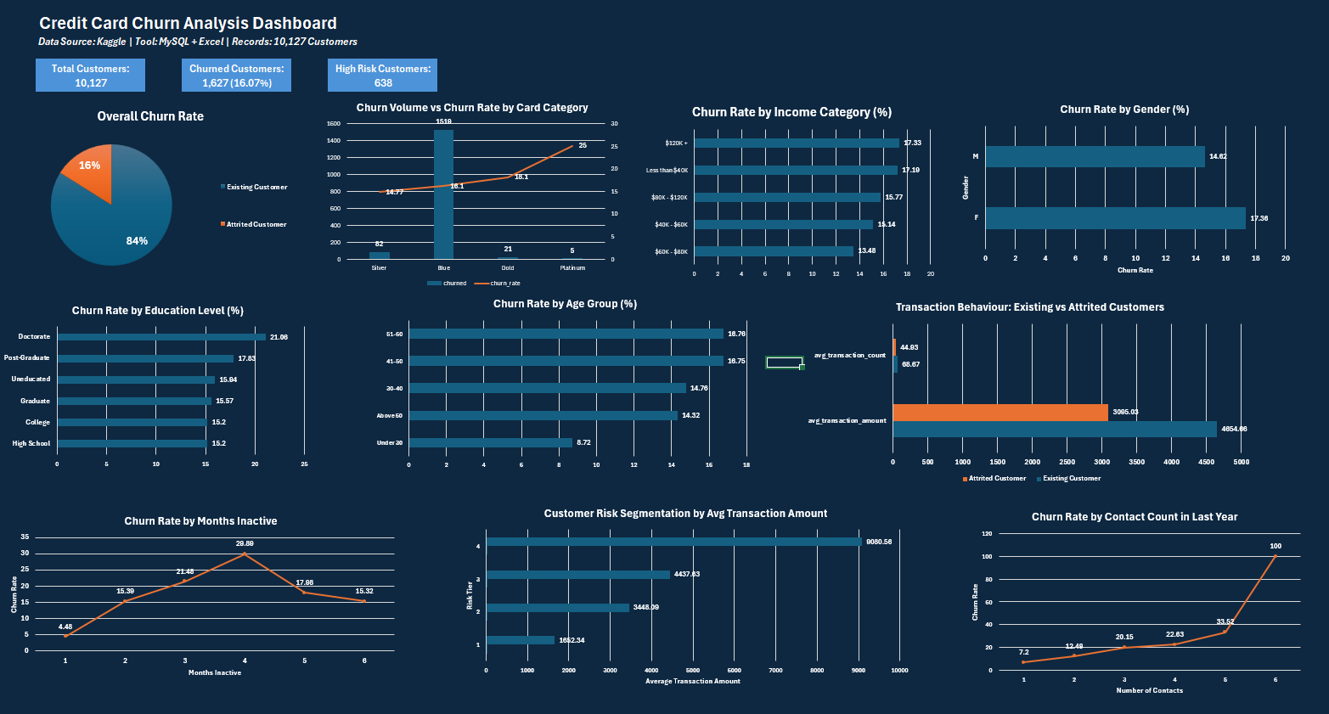
- Conclusion
This analysis successfully identified the key drivers of customer churn for a credit card business. The overall churn rate of 16.07% is significantly high and presents a major business risk. The most critical findings indicate that declining transaction activity, increasing inactivity and repeated customer service contacts are the strongest early warning signals of churn.
Middle aged customers (41-60), female customers, highly educated customers and Blue card holders represent the highest priority retention segments. Additionally, 638 existing customers have been identified as high risk and require immediate intervention.
By acting on these insights through targeted retention campaigns, improved customer service resolution and proactive engagement with at-risk segments, the bank can significantly reduce churn and improve long term customer lifetime value.

